



Assignment

On

Multicolor LED Light

**Submitted By:**

Department of CSE

Batch: 43rd

|  |  |
| --- | --- |
| Name | ID |
| Md. Abul Hosan | 163432558 |
| Md. Faruq Hasan | 163432560 |
| Md. Rasel Hossain | 163432521 |
| E H M Jowel | 163432 |
| Julkarnain | 163432 |

**Submitted To:**

SharminAkter

lecturer

Depertment of CSE

City University.

Multicolor LED (RGB Light)

Introduction:

Object:

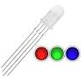Apparatus:

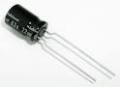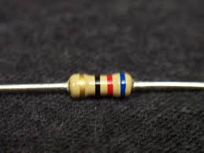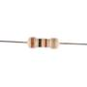

100 ohm resistor

100 ohm resistor

22 Uf capacitor

RGB LED

Diagram:

Methodology:

1. Set the IC 74c14 in the board and connect 9 v+ & v- in the circuit.
2. Set 100k ohm resistor one wire in 1, 2 & 3 input in circuit.
3. Another wire of 100k ohm resistor connect with 22uf capacitor in one wire and another wire set on 9v- in the board.
4. In the other side 100 ohm resistor set in the with series connection and connect with RGB LED light in the board.
5. Connect IC 74c14 output with 100 ohm resistor.

Outcome:

We showed in the project how to play multicolor (RGB) LED by using resistors,capacitors,RGB LED, Circuit board and some wire.

Conclusion: